Output-1

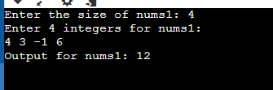

Output-2

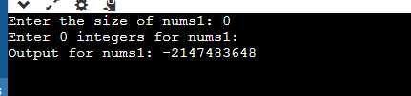

Output-3

